## Evaluate your current company/client’s architecture placing components in each of the areas:

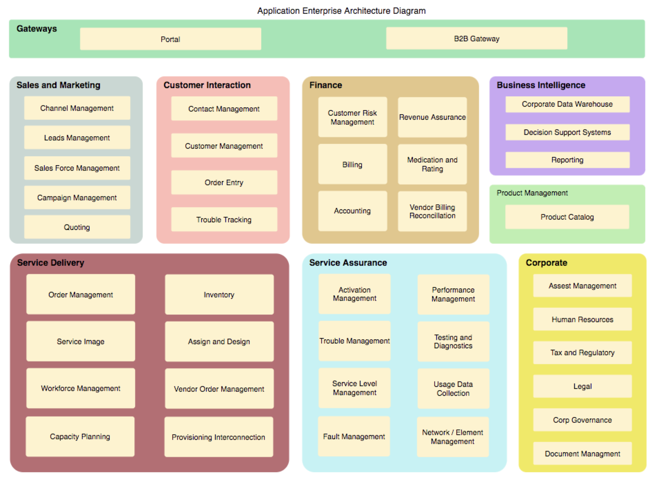

## Identify the weakest link

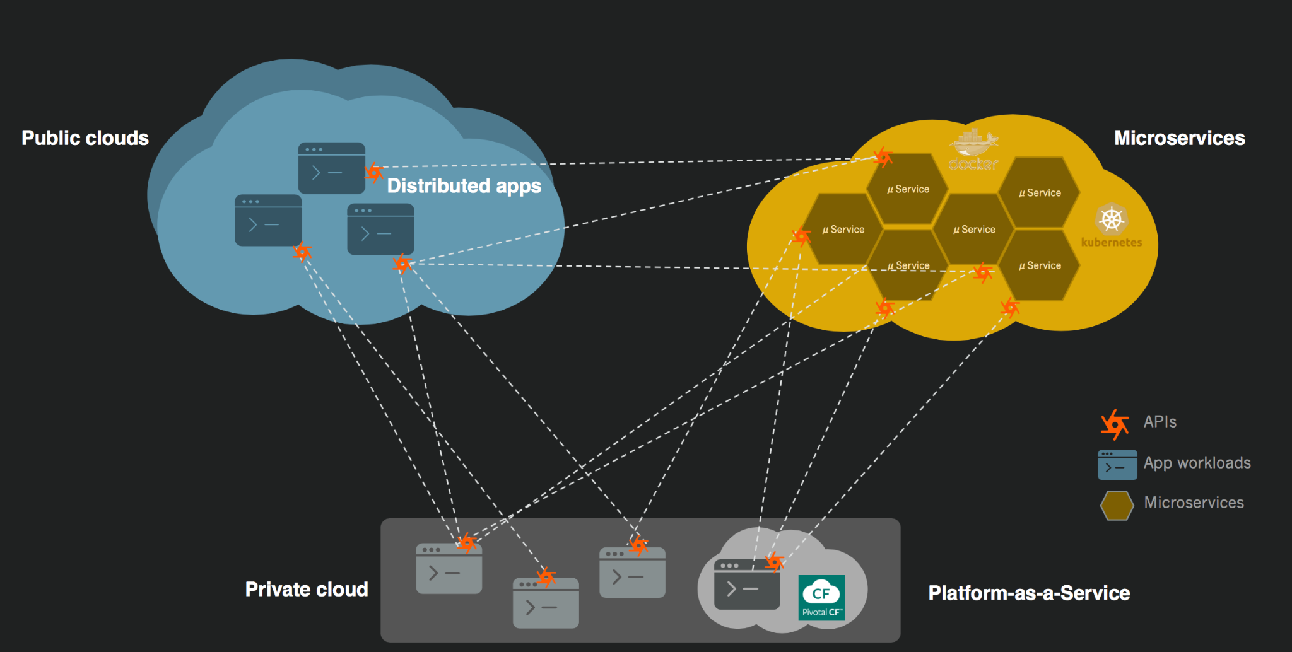

## Evaluate Global Rollout

